**INTRODUCTION TO COMPUTATIONAL CHEMISTRY**

**GAMESS PROJECT**

**BY:** M. DHANUSHRAJ

21BAI10111.

**AIM OF THE PROJECT:**

To calculate the energy of different molecules with different basis sets and different functional groups.

**Molecules:**

1. Coronene.

2. Anthanthrene.

**1. CORONENE:**

Coronene is a polycyclic aromatic hydrocarbon comprising seven peri-fused benzene rings. Its chemical formula is C ₂₄H ₁₂. It is a yellow material that dissolves in common solvents including benzene, toluene, and dichloromethane. Its solutions emit blue light fluorescence under UV light.

**STRUCTURE OF CORONENE:**

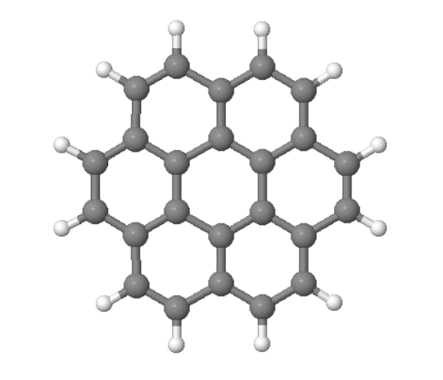

**Using functional Group None:**

|  |  |
| --- | --- |
| **BASIC SETS** | **ENERGY VALUE** |
| AM1 | -118.9362586815 a.u |
| PM3 | -111.2390412555 a.u |
| PM6 | -113.9489854321 a.u |
| STO-3G | -904.80647 a.u |
| 6-31G | -915.93476 a.u |

**Graph:**

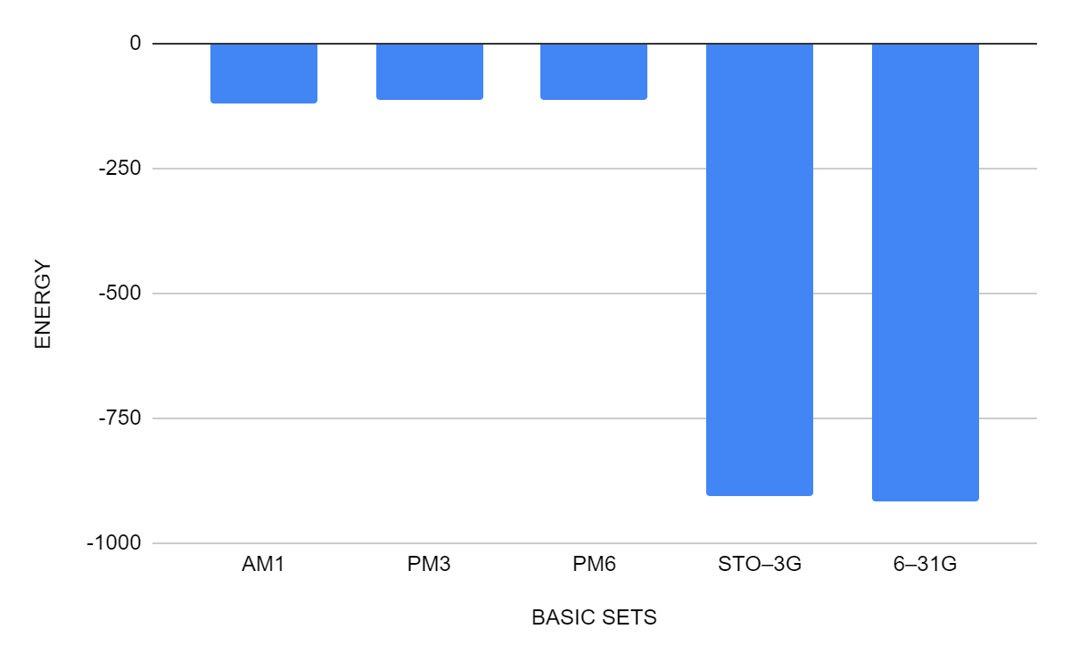

**Functional Group – B3LYP:**

|  |  |
| --- | --- |
| **Basis Set** | **Energy values** |
| STO-3G | -910.0225665458 a.u. |
| 3-21G | -916.21186 a.u. |
| 6-31G* | -921.30141 a.u. |
| 6-311G** | -921.50996 a.u. |
| 6-311G**+ | -921.51724 a.u. |

**Graph:**

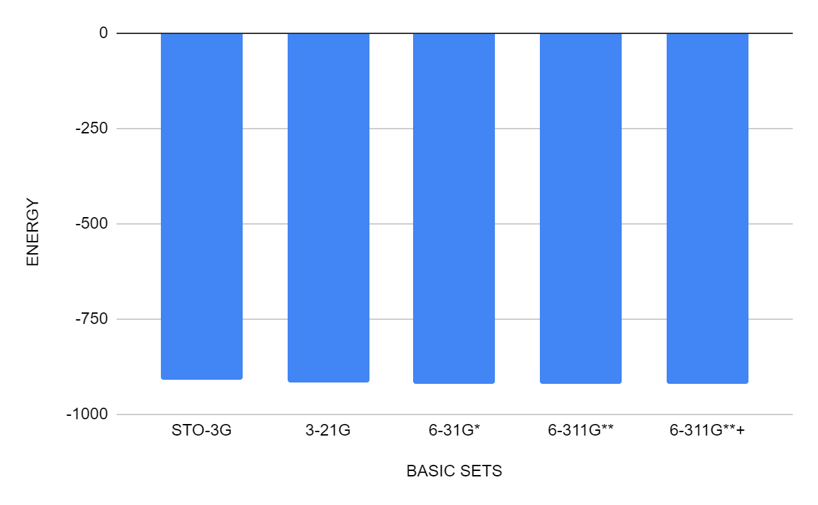

**2. ANTHANTHRENE:**

Anthanthrene is a polycyclic aromatic hydrocarbon. According to the International Agency for Research on Cancer, as of 2006 there was "limited evidence in experimental animals" that it is a carcinogen. Its structural formula is C22H12O2.

**Structure of Anthanthrene:**

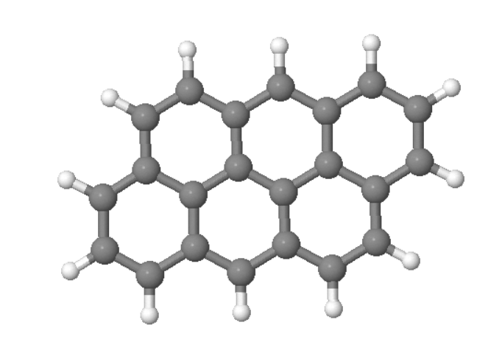

**Functional Group with none:**

|  |  |
| --- | --- |
| **BASIC SETS** | **ENERGY VALUE** |
| AM1 | -109.5314906086 a.u |
| PM3 | -102.5301140005 a.u |
| PM6 | -104.9447801412 a.u |
| STO–3G | -829.9510520629 a.u |
| 6–31G | -835.4610805971 a.u |

**Graph:**

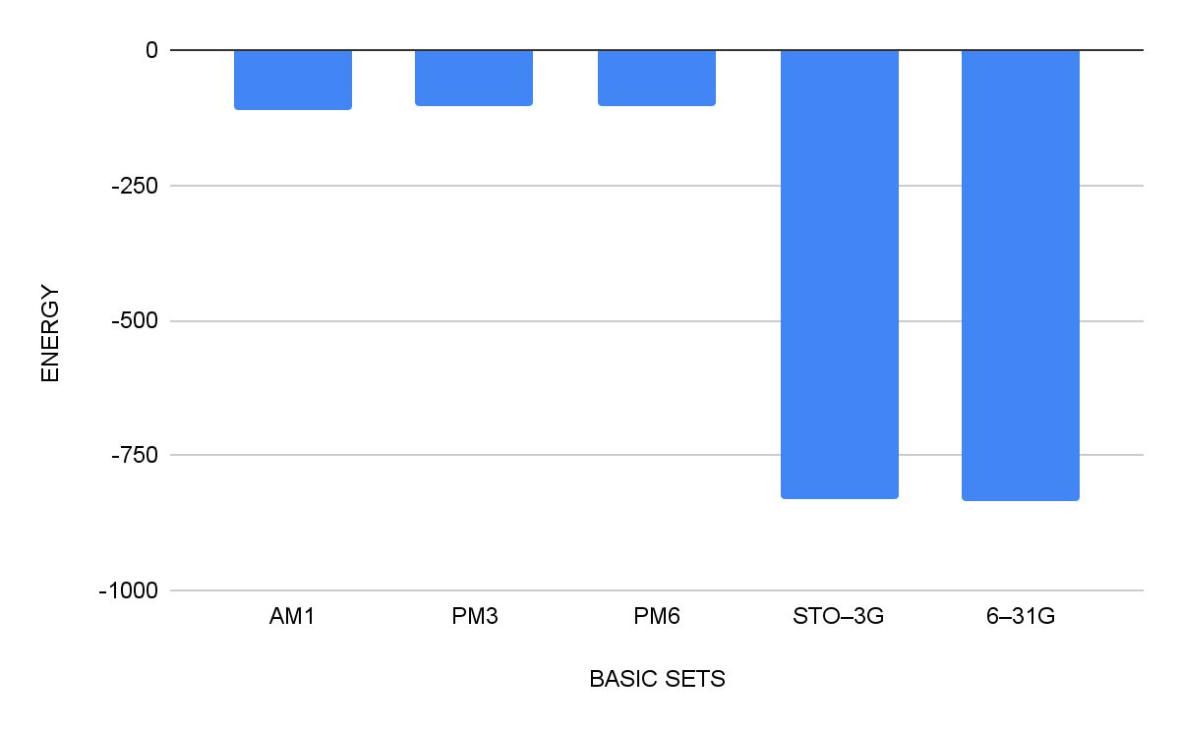

**Functional Group with B3LYP:**

|  |  |
| --- | --- |
| **BASIC SETS** | **ENERGY** |
| STO–3G | -834.7425557698 a.u |
| 6–31G | -840.4429614434 a.u |
| 6-31G* | -845.1090863088 a.u |
| 6-311G*+ | -845.3045860721 a.u |
| 6-311G**+ | -845.3017179298 a.u |

**Graph:**

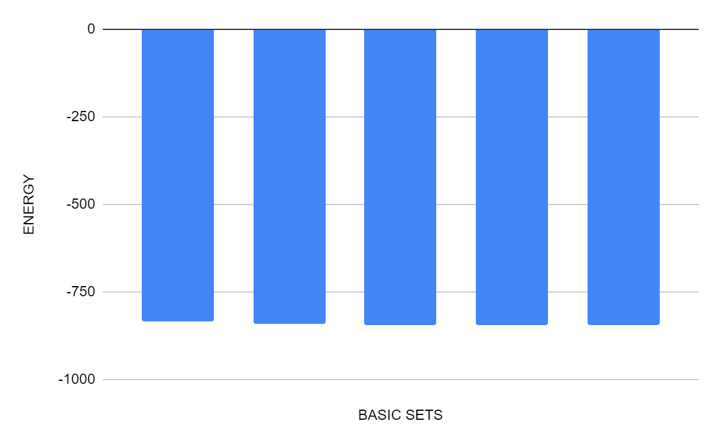

**Conclusion:**

**1. Result from the Coronene Analysis:**

From the DFT functional group with none, we come to know that in the 6-31G basis set, the molecule coronene have the less energy, so it is more stable in this basis set and in the AM1 basis set, it have higher energy compared to other basis sets so it is less stable in AM1 basis set.

From the DFT functional group with B3LYP, we come to know that in the 6-311G**+ basis set, the molecule coronene have the less energy, so it is more stable in this basis set and in the STO-3G basis set, it have higher energy compared to other basis sets so it is less stable in this basis set.

**2. Result from the Anthanthrene Analysis:**

From the DFT functional group with none, we come to know that in the 6-31G basis set, the molecule anthanthrene have the less energy, so it is more stable in this basis set and in the PM3 basis set, it have higher energy compared to other basis sets so it is less stable in PM3 basis set.

From the DFT functional group with B3LYP, we come to know that in the 6-311G*+ basis set, the molecule anthanthrene have the less energy, so it is more stable in this basis set and in the STO-3G basis set, it have higher energy compared to other basis sets so it is less stable in this basis set.

**\*\*\*\*\*\*\*\*THE END\*\*\*\*\*\*\*\***